**Thesis Title:** Cold plasma interaction on germination and Cuminaldehyde content in spice seed cumin (*Cuminum cyminum*)

**CHAPTER I**

**INTRODUCTION**

This chapter indentures with the essential information about the germination and seedling growth characteristics cumin seed, the extraction efficiency of cumin essential oil and their health benefits, the effect on the Cuminaldehyde component due to non-thermal plasma and its scope towards enhancing germination percentage and other growth characteristics. The chapter also examines the appropriate rationale for the undertaken study. The contents of the chapter include;

* 1. *Study on spice seed Cuminum cyminum L., its essential oil and flavor compound (Cuminaldehyde).*
  2. *Emerging technology applications for improving seed germination, seedling growth, and essential oil extraction efficiency.*
  3. *Scope of non-thermal plasma to improve germination rate, seedling growth, and extraction efficiency of different seeds essential oil.*
  4. *Objectives*
  5. *Study on spice seed Cuminum cyminum L., its essential oil and flavor compound (Cuminaldehyde).*

India is contemplated as the land of spices and near about 53 major spices are grown in the country. Spices such as cardamom, black pepper, turmeric, ginger, cumin, chili, cinnamon, fennel, coriander, and fenugreek are the economic backbone for a large number of Indians. Most of the spice originates at the pan-tropical region and some; specifically, the herbal spice is temperately originated and is cultivated in many countries from varied geographical regions.

Cumin (*Cuminum cyminum* L.) is commonly known to be ‘Jeera’ and it is an annual herb belonging to the Umbelliferae family of dicotyledonous group grown and as *rabi* crop. The Levant, Upper Egypt, and the Mediterranean are the origin of cumin, and it is grown and used as a seed spice from the ancient times (Heywood & Skoula, 1999). Cumin is grown as a drought-tolerant, semi-tropic, or tropic crop from its seeds and usually sown from October until the beginning of December in India (Arora et al., 2008). Cumin is familiar for its enriched flavor among all spices and Indian stands one among the largest producers and consumers in the world. Rajasthan, Gujarat, and Haryana are the largest producers of cumin in India (Dhandhalya et al., 2019).

The nutritional composition of the *Cuminum cyminum*. L seeds per 100 g comprise of energy 370 kcal (1570 kJ), dietary fiber 10.5 g, carbohydrates 44.24 g, Protein 17.81 g, fat 22.27 g, thiamine (Vit. B1) 0.628 mg, water 8.06 g, riboflavin (Vit. B2) 0.327 mg, vitamin B6 0.435 mg, niacin (Vit. B3) 4.579 mg, vitamin E 3.33 mg, vitamin C 7.7 mg, iron 66.36 mg, calcium 931 mg, phosphorus 499 mg, magnesium 366 mg, sodium 168 mg, zinc 4.8 mg, potassium 1788 mg, and other trace elements (U.S.D.A, 2008).

Cumin demand is fairly growing in the domestic as well as international market by playing an important role in the national economy (Trivedi et al., 2019). However, due to non-availability of quality seeds, less adoption of seed production technologies, uneven and slow germination, microbial load on quality seeds, unscientific and unhygienic post-harvest handling of seeds, the infestation of pests and diseases, traditional harvesting and processing methods, decrease in production and productivity of cumin is seen year after year (Trivedi et al., 2018). Poor seed germination and physical purity of seeds are responsible for the deprived establishment of plant population and lead to pest attack in field conditions which causes poor seed yield. Therefore, seed pre-treatment is one of the methods practiced for good quality seed production not only to reduce the deadly effects of damage to seed viability and vigor but also offers better avenues for its establishment, growth, and development of seedlings. Even though various seed treatments are followed before sowing to improve germination percentage and seedling growth, reports on seed- longevity and pre-sowing treatment studies on cumin are scanty.

The most significant chemical component of cumin is essential oil content (2 % to 5 %) which is pale to colorless depending on regional variations and age of seeds. The suitable seeds of cumin are subjected to essential oil production, both as coarsely ground seeds or whole seeds. Whole seeds are subjected to hydro-distillation when freely alcohol-soluble oil with a strong odor is needed. The percentage of oil yield obtained ranges from 2 to 5 %, depending on whether coarsely grounded seeds or the entire seed is distilled. The essential oil is kept in well-sealed glass bottles or aluminum containers. The characteristic cumin odor is due to the aldehydes present in essential oil, namely, cuminaldehyde. Chemical composition of the cumin essential oil presents; α-pinene, myrcene, limonene, 1-8-cineole, p-menth-3-en-7-ol, p-mentha-1, 3-dien-7-ol, caryophyllene, β-bisabolene, β-pinene, P-cymene, β-phellandrene, D-terpinene, cuminaldehyde, cuminyl alcohol, β-farnesene, α-phellandrene, α-terpinene, myrtenol, cis and trans sabinene, α-terpineol and phellandral (Nadeem & Riaz, 2012). Specific characteristics of the essential oil are: specific gravity (25 ℃/25 ℃) 0.905 to 0.925, optical rotation (20℃) +3 to +8, refractive index 1.491 to 1.506, solubility (80 % ethanol) 8 vol and aldehyde (as cuminaldehyde) 40 to 52 % (Peter, 2001).

Cuminaldehyde (4-isopropyl benzaldehyde), the flavor compound with molecular formula C10H12O is an organic compound constituent of cumin essential oil with many health benefits (Nadeem & Riaz, 2012). It has antimicrobial, strong larvicidal, chemoprotective, and antioxidant activities along with superoxide anion scavenging ability and anti-mutagenic properties (Derakhshan et al., 2007; Krishnakantha & Lokesh, 1993; Rathore et al., 2013). Cuminaldehyde compound derived from cumin essential oil is a phytochemical constituent with medicinal value to cure gastrointestinal, nervous, immune, and reproductive system problems (Rathore et al., 2013). Bacteria and pathogenic microorganism growth inhibition and prevention of food spoilage are also done by cuminaldehyde in cumin (Balacs, 1993; Carlos & Harrison, 1999; Pawar & Thaker, 2006). Therefore, estimation of the non-thermal plasma effect on the cuminaldehyde compound is required.

Cumin (seeds/powder) is used in sausages, cheese, soaps, pickles, cakes, bread seasoning, *etc*. Besides, volatile oil or essential oil extracted from seeds or powder is used in liquor flavoring, medicines, and perfumes (Akbar, 2020). Apart from the culinary value, cumin is extensively practiced in ayurvedic medicines (Srivastava, 1989). Traditionally, it is adopted as herbal medicine and as natural remedies in settling the stomach, stop flatulence, jaundice, indigestion, diarrhea, suppressing muscle spasms, and prevent gas formation in the stomach (Dhandapani et al., 2002). In addition to this, cumin also lowers blood pressure, strengthens bones, treat the eye, and reduce seizures (Singh et al., 2017). Cumin powder is used as a suppository and poultice and can be taken orally to increase energy, reduce stress, and to obtain resistance against infections (Jeganathan et al., 2017). The essential oil, derived from steam distillation, is used in desserts, flavor alcoholic beverages, and condiments. It is also added in creams, perfumes, and lotions as a fragrant component (Jabeen et al., 2017). Cumin seeds are blended in cooking and the oil is used in flavor foods. A popular drink called Jeera water made by boiling cumin seeds is beneficial in curing heart disease, vomiting, chronic fever, swelling, tastelessness, and poor digestion (Saxena et al., 2015).

* 1. *Emerging technology applications for improving seed germination, seedling growth, and essential oil extraction efficiency.*

The seed is a major independent structure responsible for the generation of plants by maintaining its germplasm and improving species diversity along with production capacity (Sharififar et al., 2015). Germination is defined as the process of initiating water uptake from inactive dry in order to develop an embryonic axis (J. Bewley & Black, 1994). Therefore, seed germination plays an important stage in plant life and it is influenced by both extrinsic and intrinsic factors. Water, oxygen, light, and temperature are the most important factors responsible for seed germination (Raven et al., 2005). During a suitable condition, seed germination and its establishment take place rapidly. Whereas, an intrinsic block occurs during extreme conditions of germination called, dormancy; is a mechanism that holds back germination during the unfavorable ecological condition, when the sustenance of seedling chances is very short (J. D. Bewley et al., 2006). Hence, dormancy has to be removed for the initiation of germination action in seed. The simplest method to overcome dormancy is controlling the humidity, temperature and salinity of the environment in which seeds are kept initially (Baskin & Baskin, 1998). Though the germination rate at the initial stage as well with the above methods during transplantation of nursery seedling into the actual field, they showed a reduced growth rate. Therefore, chemical method i.e. artificial plant hormones such as gibberellic acid and abscisic acid were used to overcome dormancy (Sozzi & Chiesa, 1995). Seed scarification and stratification are practiced to eradicate the dormancy period and hence enhanced the germination. Irrigation is also an important factor that maintains the germination level. But in the present scenario, the supply of quality water at the required level to the fields is a matter of concern due to its scarcity. The most commonly practiced method to improve germination is through the application of fertilizers and pesticides (Ramteke et al., 2013). It was found that common fertilizers such as urea, diammonium, phosphate, and several other pesticides were used to enhance seed germination yield. Though the level of yield increased through fertilizer and pesticide application, their adverse effects on living organisms and the environment remained a major concern.

The power of germination and agricultural seeds growth yield is improved by the application of physical and chemical methods that lead to genetic dissimilarity, structural damage in seeds to a higher extent and cause undesirable effects to nature and life. However, in recent years, an effort has been taken to check the impact of non-thermal technologies (high-pressure processing, ultrasound, pulsed electric field, ozone processing, magnetic field, ultraviolet and pulse light, non-thermal plasma, microwave radiation, plasma-activated water, and electrolyzed water) on seed germination and seedling growth rate by breaking dormancy in seeds (Asadi Samani et al., 2013; Harris et al., 2001; Violleau et al., 2008; Waskow et al., 2018). Hence, the use of these novel technologies will signify a good score for enhancing agricultural production. These evolving techniques offer many other returns over time-honored physical and chemical treatments. Firstly, the pesticide amount is reduced, leading to lowering the harmful impact on the living organism and environment. Second, the genetic deviation caused in the seeds is very low. In addition to this, these emerging techniques can also be applied to seed during storage and as a disinfectant before sowing (Joshi et al., 2013). The reason behind the positive and negative impact of non-thermal technologies with their mechanism of action is briefly explained in pictorial form by Rifna, E. J., *et al* (2019).

In recent years, there has been an increase in demand for essential oils extracted from various genera of spices and aromatic plants distributed worldwide. The oils normally bear the name of the plant species from which they are derived. Essential oils are so termed as they are believed to represent the very essence of odor and flavor. To the fact, those have continuous discoveries of their multifunctional properties and increasing their role in food and beverages as flavorings, as fragrances in pharmaceutical, industrial, perfume, and agricultural products. Foremost the new properties of many essential oils, such as antifungal, antibacterial, anti-inflammatory, and antioxidant activities have been found and confirmed by agricultural scientists. With the continual bombardment of viral, bacterial, parasitic, and fungal contamination in our world, essential oils are a great benefit to help protect our bodies and homes from pathogens. Therefore, there is a need to build a strong immune system and essential oils helps to give it. Many studies have been carried out on improving essential oil extraction, such as the use of microwave heating (Behera et al., 2004), ultrasound-assisted extraction (Allaf et al., 2013; Sereshti et al., 2012), supercritical CO2 extraction (Goodarznia & Eikani, 1998; Saxena et al., 2015) and non-thermal plasma (Pragna et al., 2019). But to the best of our knowledge, no reports are available on the non-thermal dielectric barrier discharge (DBD) plasma-assisted extraction intending to enhance the extraction rate of cumin essential oil during hydrodistillation. It is therefore necessary to optimize the operating conditions of the plasma treatments on the essential oil extraction process.

* 1. *Scope of non-thermal plasma to improve germination rate, seedling growth, and extraction efficiency of different seeds essential oil.*

Plasma is recognized as the fourth state of matter shaped on energizing the gaseous molecules. It is a combination of high-velocity electrons, ionized atoms and molecules, free radicals, atoms in their ground and excited state, and UV radiations (Ramanan et al., 2018). When the gaseous atoms are excited by high energy inputs like the microwave (Chen et al., 1999), radio frequency (Park et al., 2001) or electric field (Chen et al., 2004), the electrons will expel out of the atomic orbits. This results in the formation of ions and free electrons. The free electrons on impact with other electrons, positive ions, and stable molecules lead to the production of radicals and non-radical species. The feed gas used for plasma generation decides the composition of reactive species.

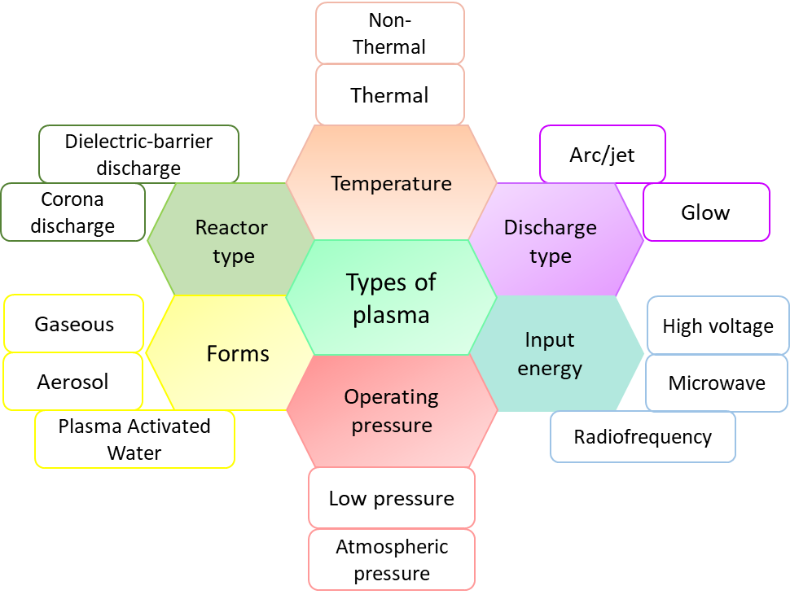Plasmas are categorized based on different attributes such as temperature, operating pressure, discharge type, input energy, and type of reactor depending on the thermal equilibrium between the electrons and the gas molecules; it is classified into thermal and non-thermal plasma (figure 1). Constituents of non-thermal plasma are shown in figure 2. When an electron collides on another electron, there occurs a momentum transfer between them, which tends to set them in thermal equilibrium with the gaseous mixture. This thereupon increases the temperature of the plasma instigating thermal plasma production, whereas, in the case of non-thermal plasma, the electrons are in a thermal non-equilibrium (Mahendran, R., Abirami, C. K., & Alagusundaram, 2017). Massive energy is required for the production of thermal plasmas as the number of electrons required to maintain the thermal equilibrium is more, while relatively lesser energy is sufficient for non-thermal plasma production (Urashima et al., 2000). Nonetheless, the energy requirement also depends on the operating pressure of the system. Low-pressure systems require reduced power inputs compared to atmospheric pressure systems.

Figure 1: Classification of plasma

Dielectric Barrier Discharge (DBD) plasma is characterized according to reactor configuration consisting of a dielectric or an insulating layer covering the electrodes to facilitate the generation of glow plasma rather than the formation of arc (Corke et al., 2010). DBD plasma is considered to be advantageous as it enables the production of non-thermal plasma at the near atmospheric pressure conditions (Kogelschatz, 2003). Also, the enhanced sustainability of discharge current across the electrodes precludes glow to arc transition which in turn results in higher stability of reactive plasma species (Shi et al., 2006).

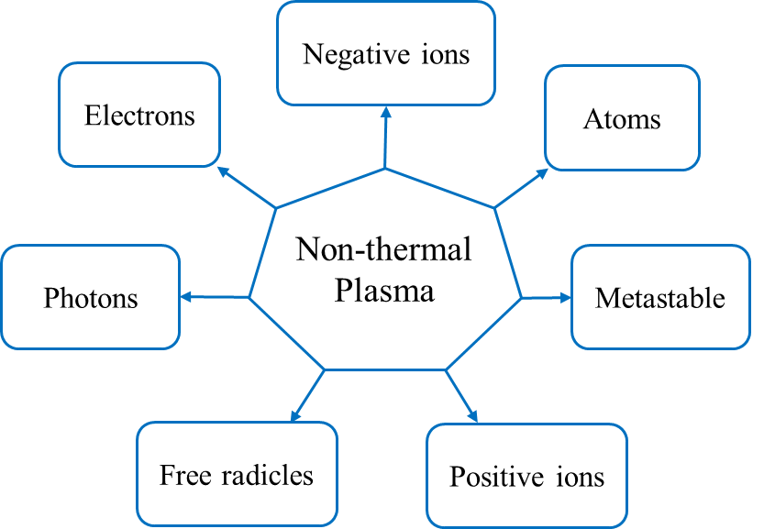

Figure 2: Non-thermal plasma constituents

When a plasma reactor, actuates in the proximity of water molecules, either direct or indirect ionization occurs resulting in the generation of ‘Plasma Activated Water’ (PAW) with immense hydroxyl radicals and acidic nitrogen species (Kamgang-Youbi et al., 2009). Production of PAW by direct ionization involves in-situ plasma generation by straight through energizing of water molecules in a liquid or a vapor form whereas indirect ionization involves the spurts of reaction between the produced plasma species and the ex-situ water molecules (Liu et al., 2012).

The elements of plasma interact extensively with the food system bringing in multiple reactions include, oxidative stress induced by the reactive species and free radicals; electro permeation caused by the ions; surface etching or disruptions due to the accelerated electrons; and the UV actuated DNA mutations are responsible for its more comprehensive application (Niemira & A, 2012; Volkov et al., 2019). In this regard, the presence of UV-A, nitrogen dioxide, nitrate, and nitrite in cold plasma acts as seed dormancy breakers and induce germination by improving the percentage of germination (Bethke et al., 2005; Hamid & Jawaid, 2011). ROS initiates many genetically expressed chemical cascade reactions, and metabolic cell activities are accelerated, especially inside the mitochondria of seed (Violleau et al., 2008) and help in the expelling of essential oil. The existing studies on stimulation of germination and seedling growth along with high essential oil extraction ability using non-thermal plasma exhibit the potentiality of the technique (Bormashenko et al., 2012; Pragna et al., 2019; Zahoranová et al., 2016). However, the low-temperature process makes cold plasma as a suitable alternative for thermal processing in the food industry.

* 1. *Objectives*

Considering the need and rationale of the study, as discussed in the above sections, the following objectives were undertaken;

1. Influence of non-thermal plasma on the germination rate of *Cuminum cyminum* seeds.
2. To study the effect of non-thermal plasma on Cuminaldehyde in cumin essential oil.